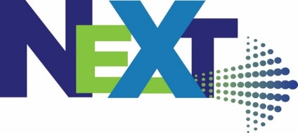

The Event for Technology, Manufacturing & Innovation

Wednesday, September 21, 2022
Ramada by Wyndham, Liverpool, NY

NEXT Tech Innovation Showcase Exhibitor: Space Reservation Form

We are excited to be bringing back the NEXT Innovation Conference which will be held September 21 in Liverpool, NY and will again be hosting a Tech Showcase. If you would like to participate as an exhibitor, please complete this form to reserve your space. 2022 NEXT Tech Showcase Reservation Forms will be accepted on a first-come/first-served basis until we have reached capacity.

Complete the following Tech Showcase reservation form and send to: mmetzgar@tdo.org. Once received, an invoice will be sent for payment. NEXT Tech Showcase Fee: $50.00
- - - - - - - - - - - - - - - - - - - - - - - - - - - - - - - - - - - - - - - - - - - - - - - - - - - - - - - - - - - - - - - - - - - - - - - - - -
Organization:

Email Address for NEXT Tech Showcase Invoice:

Your organization’s (2) Tech Showcase/Conference Registrant Names / Email Addresses:
Conference Attendee Name | Email Address

Exhibits include a 6’ banquet table with linen and 2 chairs. All exhibitors must set up between 7:00 – 7:30 a.m. on Wednesday morning. New this year – we will have a Job Board – if you have job postings, please plan to bring to post on our Job Board.
Additional requests:
⃝ Electricity ⃝ Wi-Fi
⃝ Additional 6” Table (additional table charge) ⃝ Other:

A reception will be held in the Tech Showcase at the end of the program. Please note if you would like to provide a door prize for drawings to be held during the program reception:
- Yes, we will provide a door prize

Hotel Accommodations: A limited number of hotel rooms are available at our discounted room rate (Single/Double) of $115.00 + tax. When reserving, mention “NEXT 2022 Innovation Conference.” The room block will be released as of August 21. Hotel reservations: 315-457-1122.

Return NEXT Tech Showcase Registration Form to: mmetzgar@tdo.org

Conference details: www.next-syr.com

